TO: Professor Linninger
FROM: Melika Salehabadi
DATE: July 30, 2019
SUBJECT: Weekly Report

Abstract
Regarding our previous discussion, I have finished the MATLAB code for making the cross section at center point of the tube. I have reformatted the Delphi code in MATLAB. I have added the function of “make cross section” to my bifurcation geometry code.

Results
The most important part of the updated version of my MATLAB code and the generated plots are explained in this section. The code below was used to make cross sections from t=0 to t=0.3.

function transGeom = SurfMesh(t1,t2,NSegments,e1,e2,e3,crossSection,splineCtrlPts)
dt=(t2-t1)/NSegments;
e1 = reshape(e1,[3,1]);
e2 = reshape(e2,[3,1]);
e3 = reshape(e3,[3,1]);
e11=e1;
e12=e2;
e13=e3;
tcutoff=0.3;
saveCrossSection{1}=crossSection;
tt=t1:dt:t2;
ppi(:,1)=splineCtrlPts(:,1);
A=crossSection;
for i=2:NSegments
ppi(:,i)=BezierSpline(tt(i),splineCtrlPts);
vi=BezierTangent(tt(i),splineCtrlPts);
alfa=(tt(i)/tcutoff)*(tt(i)<tcutoff)+(1-tt(i))/tcutoff*(tt(i)>(1-tcutoff))+1*(tt(i)>tcutoff&tt(i)<(1-tcutoff));
nn1 = e13*(1-alfa)+alfa*vi;
aaProj = dot(nn1,e11)*normalize(nn1);
e1i = normalize(e11-aaProj);
e3i = normalize(nn1);
e2i = normalize(cross(e3i,e1i));
JJ = [e1i,e2i,e3i];
R = JJ/[e11,e12,e13];
A = transferAndRotate(A,R,ppi(:,i-1),ppi(:,i));
saveCrossSection{i+1} = A;
e11 = e1i;
e12 = e2i;
e13 = e3i;
hold on
plot3(A(1,:),A(2,:),A(3,:),'r-');
end
transGeom=saveCrossSection;
end

Fig. 1 and Fig. 2 show the resulting curves generated by the MATLAB code above in different views.

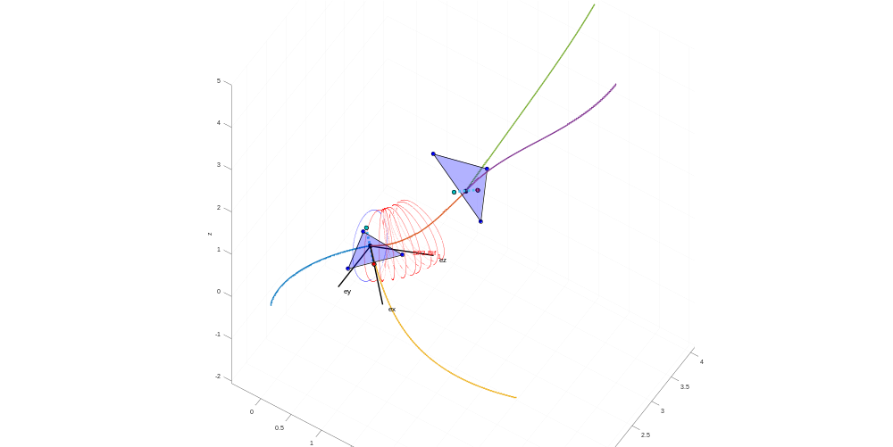
Figure 1: cross sections from t=0 to t=0.3

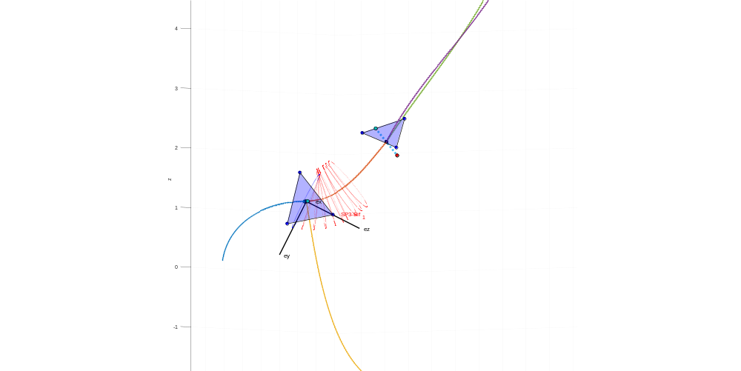
Figure 2: cross sections from t=0 to t=0.3 in different view

Conclusions
I wrote a MATLAB program to draw the cross sections from t=0 to t=0.3. The results show that the angle between the first cross section and the velocity vector, which is called Alfa, will be decreased. Then, at t=0.3 the cross section plane is perpendicular to the center line of the tube. As it is shown in Fig. 1, the Alfa is decreased linearly and at t=0.3 the Alfa is zero.

Future Work
- I am documenting the whole process of rewriting the Delphi code in MATLAB.
- I will work on the next part of the Delphi code.

